龍華科技大學企業管理系碩士班
碩士論文口試申請表
填表日期：民國 YY 年 MM 月 DD 日
研究生姓名 | (Student Name) | 組別 |  |  | 學 號 | (Student ID)
論文題目 | (Chinese Thesis topic)  (English Thesis topic)
口試時間 | Year 年Month月Day 日 Am/Pm午 Hr 時 Min分
口試地點 | (Location of Defense) |  |  | 指導教  授簽章 | (Signature by Advisor)
所 長 簽  具 意 見 | (Comments of Department Chair)
注意事項：一、請檢附論文中英摘要、學術研究倫理6小時證明、研討會發表證明、
論文電子檔、論文相似度比對結果(以學校所提供的比對系統為主)
二、口試委員之聘請，由指導教授推薦委員名單，再由所長遴聘3名委員，校內委員2
名，校外委員 1 名。
如指導教授或共同指導教授非企業管理系碩士班（以下簡稱本系）專任教師者，3位口試委員名單內需包含1名本系專任教師。
三、口試時，校外委員擔任委員會主席。
考試委員 | 最高學歷 | 現職職稱 | 通 訊 處 | 電 話 | 備 註
Committee  Member’s  Name | Committee  Member’s  Highest  degree | Current  School and  Department Name  And Position/Title | Address | Phone Number  E-mail | Note
Committee  Member’s  Name | Committee  Member’s  Highest  Degree | Current  School and  Department Name  And Position/Title | Address | Phone Number  E-mail | Note
Committee  Member’s  Name | Committee  Member’s  Highest  Degree | Current  School and  Department Name  And Position/Title | Aaddress | Phone Number  E-mail | Note
企業管理系暨碩士班論文口試流程
Apply For Thesis Defense
- 前置作業
- 填寫論文口試申請表並於口試日前3個禮拜提出申請。
- 提交口試申請表時請一併提供中英論文摘要、論文電子檔、學術倫理6小時、研討會發表證明、論文相似度比對結果。
- 口試申請表請指導教授簽名。
- 口試申請表送至所辦予所長簽核。
- 研討會發表證明。
- 學術研究倫理6小時證明。
A. Before Thesis Defense
- Fill out “Thesis Defense Application Form” from department.
- Submit your “Thesis Defense Application Form” , “Chinese and English Abstract”, “Thesis electronic file”, “Center for Taiwan Academic Research Ethics Education Certificate of Completion “, “Conference Certificate “, “Plagiarism Detection for Thesis Originality “to department office.
- Application form signed by advisor professor.
- Application form approved by department of chair.
(Completed at least 2 weeks before the day of defense)
- Submit the certificate which you participated and presented your paper in the conference to department.
- Pass six hours of academic ethics courses according to the regulations of the academic ethics courses to obtain a certificate of completion.
- 論文口試作業
- 論文當天至所辦領取「評分表」、「審定書」、「領據」。
- 論文結束後將「領據」、「審定書」交回至所辦。
B. Documents for the Day of Defense
- To get required documents from department before the day of defense.
  - Three pieces of thesis defense score list.
  - One thesis defense score record.
  - One Examiners approval record.
  - Three pieces of receipts.
- Submit required documents to department after thesis defense.
三、格式審查（至少3個工作天）
- 繳交修改後的紙本至系辦進行格式審查。
- 審查完會收到格式審查意見暨修正紀錄表。
- 請照格式審查意見修正格式，修正完後意見表簽名繳回系辦。
C. Check Thesis Writing Form (at least 3 weekdays):
- Submit your corrected thesis (printing paper) to department for writing form check when you pass the defense and corrected your thesis (advisor professor approved).
- Correct your thesis writing form and given signature on the recommendation list which department noticed you.
四、電子檔上傳（至少5個工作天，系辦2天，圖書館3天）
- 系辦收到格式審查意見表後，請e-mail電子檔論文至系辦信箱，系辦會在審定書上加上系章，寄回給申請人
- 論文系統會寄發一組帳號密碼至申請人e-mail信箱
- 請將論文上傳至下列網址http://ndltdcc.ncl.edu.tw/lhu/
- 上傳完後送出審核(審核過程中如有需修改會再退回)
審核結束後會收到e-mail告知
D. Uploading Thesis Electronic File (at least 5 weekdays):
- Submit your thesis writing form and email ba@mail.lhu.edu.tw corrected thesis.
- You will receive one set of account and password from your e-mail.
- Uploading and submit your thesis to http://ndltdcc.ncl.edu.tw/lhu/
- Checked by library system.
- Please correct the mistake if you receive the notice from system e-mail, uploading your corrected thesis for system check again.
Note: You will receive a notice when your thesis passed and completed from system uploading.
五、論文印製（至少3個工作天）
- 收到e-mail告知代表線上傳檔完成，可進行論文印製動作。
- 日間部碩士生為2本精裝本、1本平裝本(藍)
(1精裝繳至系辦、1精裝繳至圖書館、1平裝繳至教務處综業組)
- 在職班碩士生為3本精裝本、1本平裝本(紅)
(1精裝繳至系辦、1精裝繳至圖書館、1精裝繳至進修部、1平裝繳至教務處综業組)
E. Printing Thesis (at least 3 weekdays):
- When you passed thesis check from system uploading, please printing thesis follow the thesis printing rule (features of size, color, characters etc,).
- Day school master: please printing 2 hardcovers, 1 paperback
(Hardcover: 1 for department, 1 for library; Paperback: 1 for school office academic affairs)
- Non-Day school master: please printing 3 hardcovers, 1 paperback
(Hardcover: 1 for department, 1 for library; 1 for office of extension education Paperback: 1 for school office academic affairs)
六、離校手續
- 日間部碩士生須至教務處註冊組領取離校手續單
- 在職班碩士生須至進修部註冊組領取離校手續單
F. Before Leaving School:
- Day school master students please go to office academic affairs for apply the leaving school form, and follow the guidance to complete the stamp.
- Non-Day school master students please go to office of extension education for apply the leaving school form, and follow the guidance to complete the stamp.

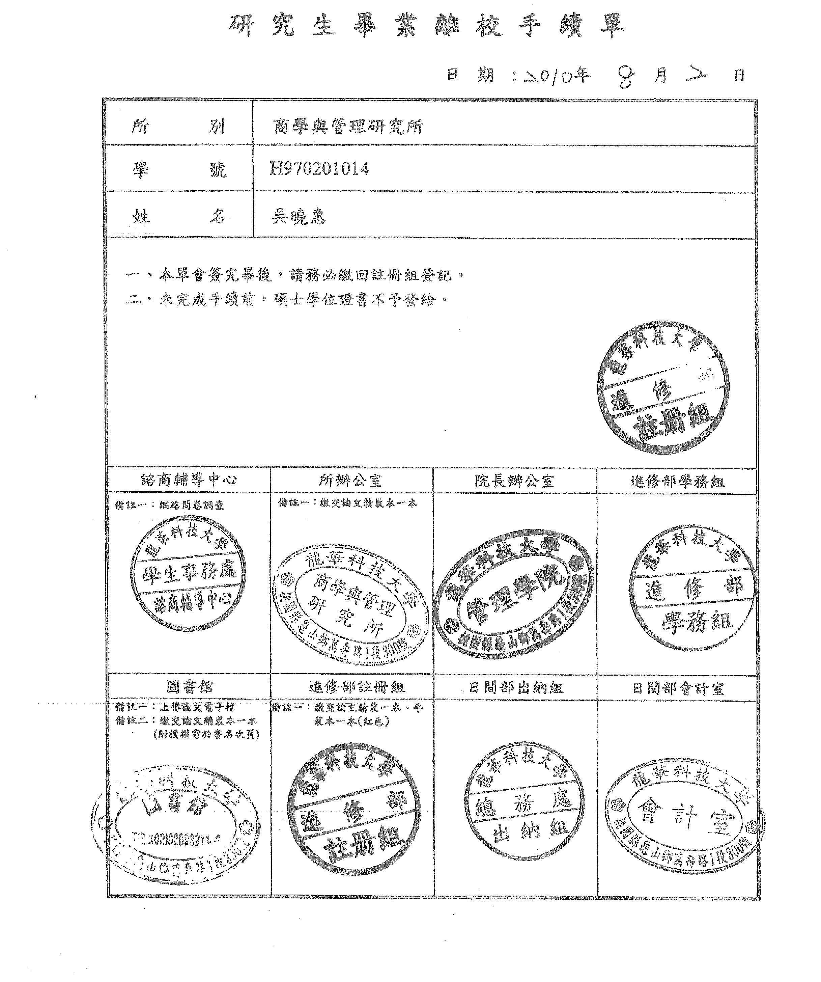
離校手續單範例

